**Project Name:** Churn Prediction

**Github Link:** https://github.com/projectsforstudents2022/Churn_Prediction.git

**Why was this project created?**

The issue is focused on the banking industry, where a bank wishes to forecast a client's churn based on past data from that customer. By "churn," the bank means that it wants to determine if a customer would default in the upcoming quarter based on their previous credit history.

**What problem is it solving?**

Predicting whether a customer would default on their debt or not based on their prior behavior is the major challenge. In addition, if someone could be identified as a defaulter, basic precautions may be taken to prevent such violations from occurring. From a bank's standpoint, it is necessary in order to sustain business and client relationships.

**Entire explanation of project**

* **PROPOSED APPROACH**

Basic libraries are imported in order to process the data. The telecom customer turnover dataset, which was collected from Kaggle, will be the dataset we use to start. The dataset contains a number of features, and we can forecast customer churn using those attributes. There are 21 columns and 7043 rows in this dataset. Both categories and numerical columns are provided. It is now time to preprocess the data. To do this, we must first observe the dataset, which entails looking at the data types of the columns as well as any additional functionality and parameters for each column. We now remove the undesired characteristics from our dataset because they are like garbage and will damage the accuracy of our model. We remove customerID because it is meaningless in the dataset and we can distinguish between each customer with ease using the row indices. By eliminating this column, the dataset should now be prepared for processing. Therefore, we must deal with categorical columns here. Once we noticed that NO and YES were contained in the dataset's count values, we had to convert them into 1 and 0, which would be simpler to analyze. Now that we have divided our dataset into dependent and independent variables, we can begin the model training procedure. Now that the preprocessing and splitting phases have been completed, it is time to start building the neural network. For this, we will utilize the TensorFlow and Keras libraries.

Here, we define the sequential model. The sequential model connects the input, hidden, and output layers in a sequential manner. Here, we define the input layer as containing all 19 columns as input, the second and third layers as being hidden layers, which contain 15, 10, and 15 hidden neurons, respectively. Finally, we apply the RelU activation function. The final stage in constructing an artificial neural model is compiling the model. The loss function, the optimizer, and the metrics that we must input as arguments are all defined by the compilation. In order to determine if our model correctly predicted true or false, we must combine the original and anticipated values at the end.

Algorithm for creating next word prediction model :

**Step 1:** Import Libraries & Load Dataset

**Step 2:** Data Analysis

**Step 3:** Data Manipulation

**Step 4:** Build Artificial Neural Network

**Step 5:** Train Model

**Step 6:** Testing & Visualization

* **DATA FLOW DIAGRAM**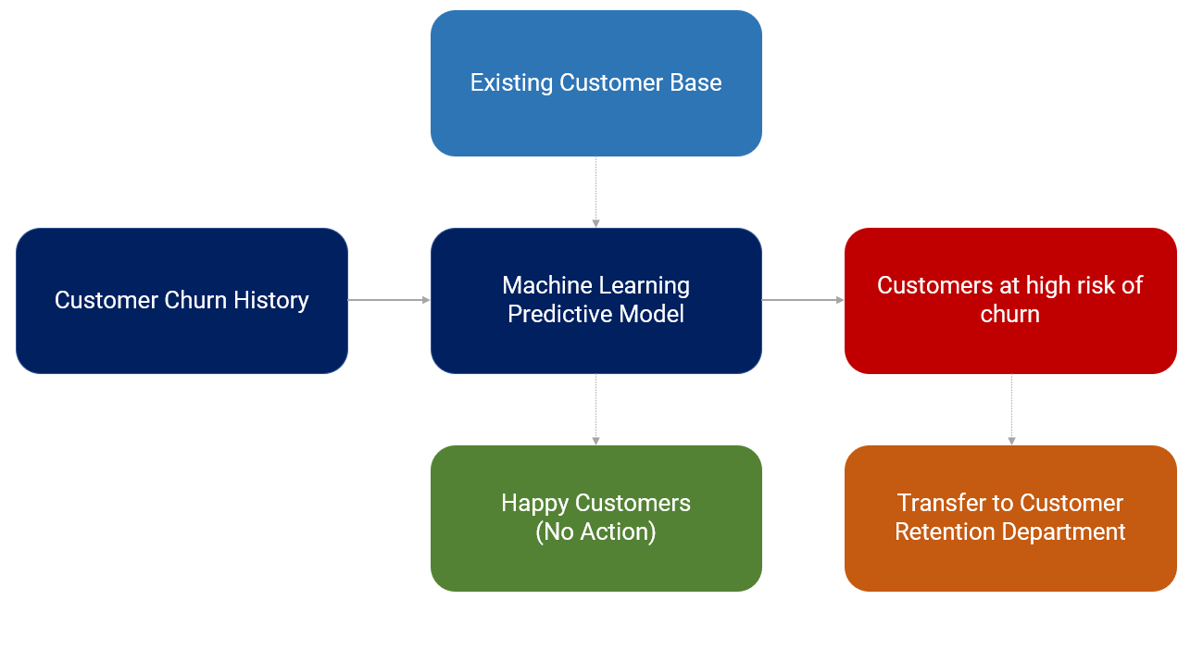
* **RESULT**

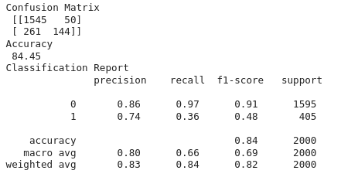

* **CONCLUSION**

Customer churn research makes it possible to reduce acquisition costs and boost marketing effectiveness, creating a strong foundation for upcoming marketing initiatives and analyses. Customer churn research provides new chances for cross-selling and upselling and is one of the beginning points for customer-driven product development, which helps to retain customers' interest and loyalty over time.